Characteristics of Standard Diodes
- Only allow current flow in one direction
- Act as a one-way gate
- Schematic symbol – the arrow shows the direction of current flow when the diode is forward biased
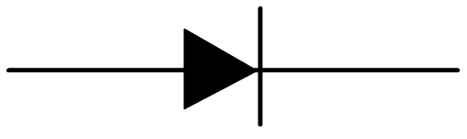
- Positive side of diode = Anode
- Negative side of diode = Cathode

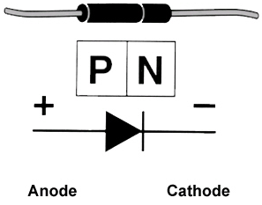
- P-N Junction – Area where the two materials meet

